Revit VSTA Samples

Revit_VSTA_Samples.rvt
Revit_VSTA_Samples.rvt can be opened by Revit Architecture, Revit Structure and Revit MEP. There are simple and common document-level macro samples included (15 C# sample macros and 15 VB.Net sample macros).
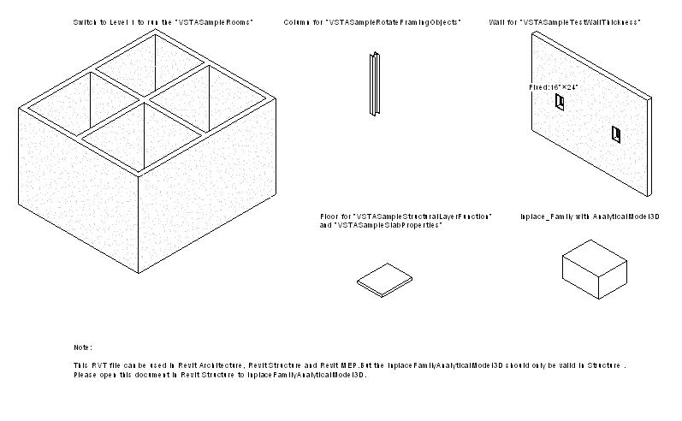
Figure 1: Revit_VSTA_Samples.rvt

C# Samples:
Sample Type | Sample Macro Name | Notes
Simple Samples | VSTASampleQuickPrint_FloorPlans  VSTASampleQuickPrint_Elevations  VSTASampleQuickPrint_Section
Simple Samples | VSTASampleFindAndReplaceText
Simple Samples | VSTASampleCapitalizeText
Simple Samples | VSTASampleFindAndReplaceWinType
Simple Samples | VSTASampleDeleteObject
Simple Samples | VSTASampleProjectInfo
Common Samples | VSTASampleCreateBeamsColumnsBraces
Common Samples | VSTASampleGridCreation
Common Samples | VSTASampleInplaceFamilyAnalyticalModel3D | Revit Structure only
Common Samples | VSTASampleRooms | Not available for Revit Structure
Common Samples | VSTASampleRotateFramingObjects
Common Samples | VSTASampleSlabProperties
Common Samples | VSTASampleStructuralLayerFunction
Table 1: Revit VSTA Samples in C#

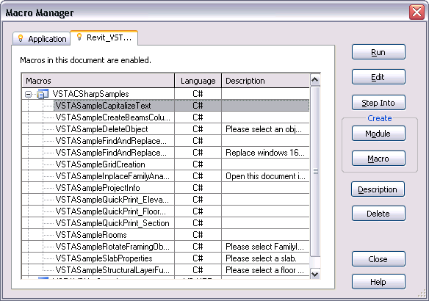
Figure 2: Revit VSTA Samples in C#

1.2. VB.Net Samples:
Sample Type | Sample Macro Name | Others
Simple Samples | VSTASampleQuickPrint_FloorPlans  VSTASampleQuickPrint_Elevations  VSTASampleQuickPrint_Section
Simple Samples | VSTASampleFindAndReplaceText
Simple Samples | VSTASampleCapitalizeText
Simple Samples | VSTASampleFindAndReplaceWinType
Simple Samples | VSTASampleDeleteObject
Common Samples | VSTASampleCreateBeamsColumnsBraces
Common Samples | VSTASampleDesignOptionReader
Common Samples | VSTASampleInplaceFamilyAnalyticalModel3D | Revit Structure only
Common Samples | VSTASampleMaterialProperties
Common Samples | VSTASampleRotateFramingObjects
Common Samples | VSTASampleSlabProperties
Common Samples | VSTASampleStructuralLayerFunction
Common Samples | VSTASampleTestWallThickness
Table 2: Revit VSTA Samples in VB.Net

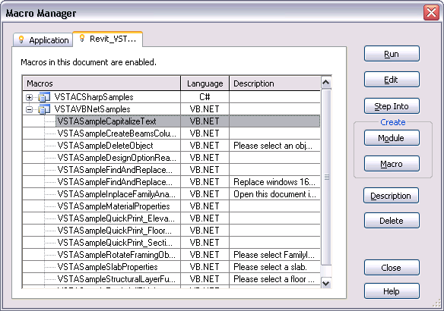
Figure 3: Revit VSTA Samples in VB.Net

- Revit_VSTA_MEP_Samples.rvt
Please open this file in Revit MEP. There are only two document-level macros (one C# sample macro and one VB.Net sample macro).

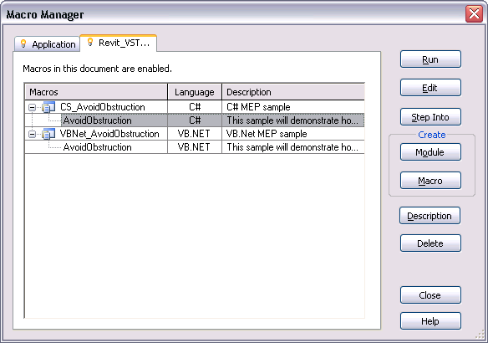
Figure 4: Revit VSTA MEP Samples

- Revit_VSTA_Family_Samples.rfa
Revit_VSTA_Family_Samples.rvt can be opened by Revit Architecture, Revit Structure and Revit MEP. There are several document-level family samples included (5 C# sample macros and 5 VB.Net sample macros).
Sample Type | Sample Macro Name | Others
Family Samples | AutoJoin
Family Samples | AutoParameter
Family Samples | GenericModelCreation
Family Samples | TypeRegeneration
Family Samples | ValidateParameters
Table 3: Revit VSTA Family Samples

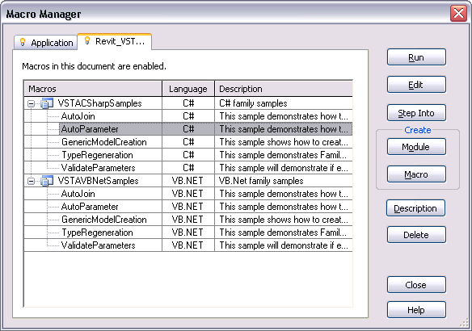
Figure 5: Revit VSTA Family Samples

Note: “AutoParameter” macro needs two files, familyParameter.txt and sharedParameter.txt, which should be placed under the same folder with this family file.

Folder “GetTimeElapsed_CSharp”
This is a C# application-level module; it contains a macro named “TimeElapsedSinceLastSave. This sample demonstrates a possible situation of application-level macros to monitor the Revit session for certain events, such as document saving.

Please copy this folder into RevitInstallPath\Program\VstaMacros\AppHookup,
Make sure the new folder as writable for debugging the macros and then launch Revit. Remind again, make sure the module’s folder as writable before debugging the macros.

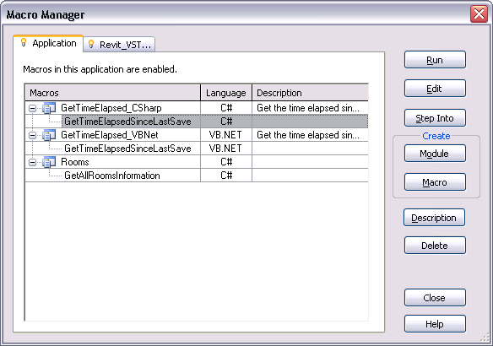
Figure 6: Application-level macro "GetTimeElapsedSinceLastSave" in C#

Folder “GetTimeElapsed_VBNet”
This is a VB.Net application-level module, please see the description above.
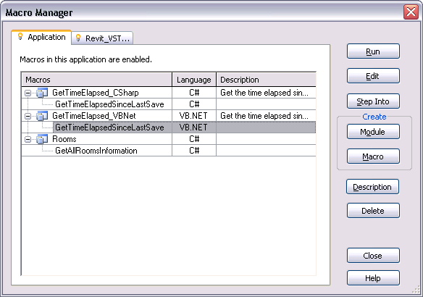
Figure 7: Application-level macro "GetTimeElapsedSinceLastSave" in VB.Net

Folder “Rooms”
This is a C# application-level module. It includes application-level “GetAllRoomsInformation” macro related files. You can copy this folder into
RevitInstallPath\Program\VstaMacros\AppHookup,
Make sure the new folder as writable for debugging the macros and then launch Revit.
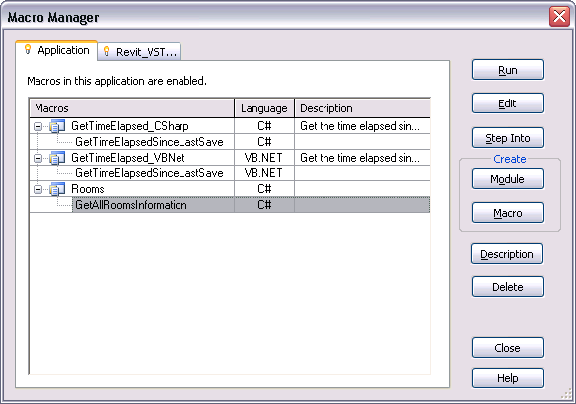
Figure 8: Application-level macro "Rooms" in C#
Note: A document-level version of the “Rooms” macro is contained in Revit_VSTA_Samples.rvt.

